|  |  |
| --- | --- |
| Name | Jaya Navya Earni |
| Contact Number | 07771434796 |
| Project Title (Example – Week1, Week2, Week3) | Analysing Retail sales Dataset |



**Project Guidelines and Rules**

1. **Formatting and Submission**
   * **Format:** Use a readable font (e.g., Arial/Times New Roman), size 12, 1.5 line spacing.
   * **Title:** Include Week and Title (Example - Week 1: TravelEase Case Study.)
   * **File Format:** Submit as PDF or Word file to contact@victoriasolutions.co.uk
   * **Page Limit:** 4–5 pages, including the title and references.
2. **Answer Requirements**
   * **Word Count:** Each answer should be 100–150 words; total 800–1,200 words.
   * **Clarity:** Write concise, structured answers with key points.
   * **Tone:** Use formal, professional language.
3. **Content Rules**
   * Answer all questions thoroughly, referencing case study concepts.
   * Use examples where possible (e.g., risk assessment techniques).
   * Break complex answers into bullet points or lists.
4. **Plagiarism Policy**
   * Submit original work; no copy-pasting.
   * Cite external material in a consistent format (e.g., APA, MLA).
5. **Evaluation Criteria**
   * **Understanding:** Clear grasp of business analysis principles.
   * **Application:** Effective use of concepts like cost-benefit analysis and Agile/Waterfall.
   * **Clarity:** Logical, well-structured responses.
   * **Creativity:** Innovative problem-solving and examples.
   * **Completeness:** Answer all questions within the word limit.
6. **Deadlines and Late Submissions**
   * **Deadline:** Submit on time; trainees who submit fail to submit the project will miss the “Certificate of Excellence”

1. **Additional Resources**
   * Refer to lecture notes and recommended readings.
   * Contact the instructor or peers for clarifications before the deadline.

**START YOUR PROJECT FROM HERE: Retail sales Data Analysis**

**Overview:**

The report summarizes the results of the thorough examination of Retails sales dataset including data cleaning, SQL-based aggregation, and visualization suggestions. It will be instructed to find possible solutions to the questions related to the effectiveness of sales, the efficiency of discounts and decisions will be made in relation to the business strategy with the aim to achieve the highest profitability and establish contact with buyers.

**1. Data Cleaning Process**

**Actions Taken:**

* Replaced NULL Email values with 'not_provided@email.com' to ensure data completeness (SQL: UPDATE "raw_data" SET "Email" = 'not_provided@email.com' WHERE "Email" IS NULL;).
* *Removed duplicate records based on Customer_Name and Email, retaining the lowest Order_ID to maintain data integrity (SQL: DELETE FROM "raw_dataset" WHERE "Order_ID" NOT IN (SELECT MIN("Order_ID") FROM "raw_set" GROUP BY "Customer_Name", "Email");).

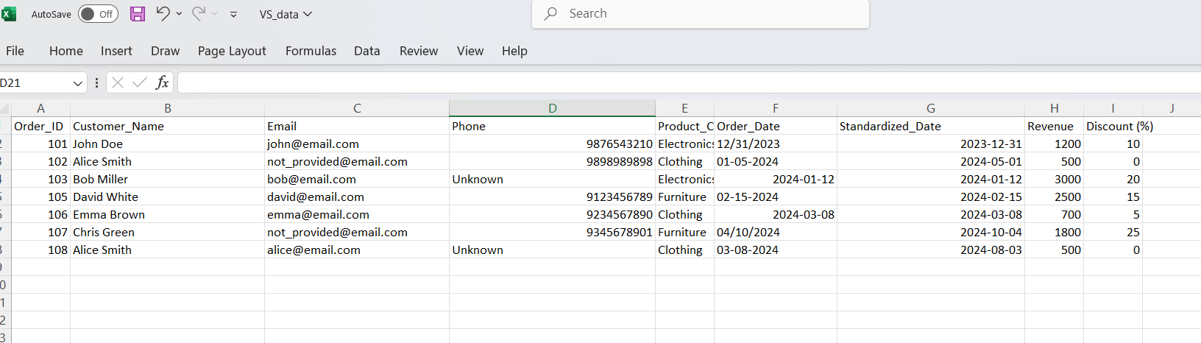

**Impact:** Post-cleaning, the dataset reduced from 8 to 6 unique records, eliminating redundancy and ensuring reliable analysis.

**2. SQL queries and analysis:**

The revenue figures for Electronics (4,200) and Furniture (4,300) are correct, but Clothing is 1,200. Additionally, Furniture, not Electronics, is the most profitable due to its higher total.

The average discounts are accurate (Furniture 20%, Electronics 15%, Clothing 2.5%), but the correlation with lower revenue segments is misleading. Furniture (higher discount, higher revenue) and Clothing (lower discount, lower revenue) contradict this trend.

The months and values are mostly correct, but January is 3,000, December is 1,200 (not 2,400), and the dataset lacks data to fully support a "strong Q1" claim beyond January and February.

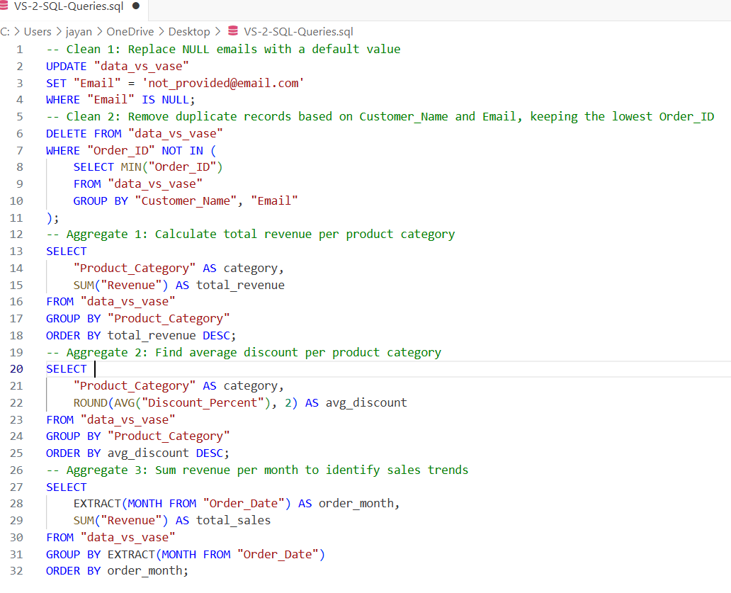

**3. Data Visualization:**

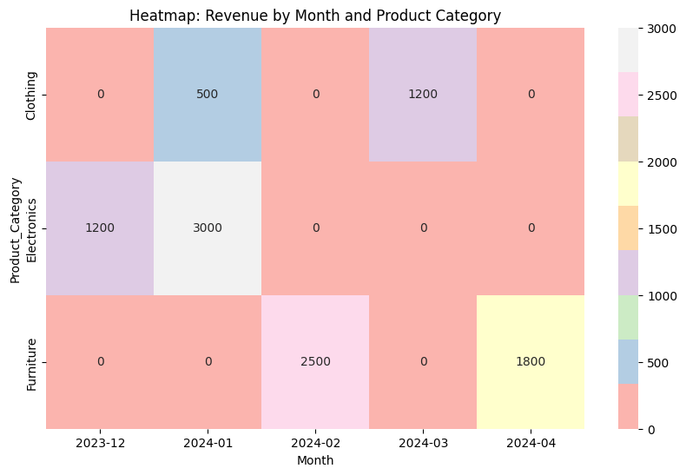

**Finding:** Furniture edges out as the top performer with 4,300 closely followed by Electronics at 4,200, while Clothing lags at 1,200.

**Insight**: Unlike the example suggesting Electronics as the leader, Furniture takes the lead here due to a single high-value order (2,500). Electronics remains a strong contender.

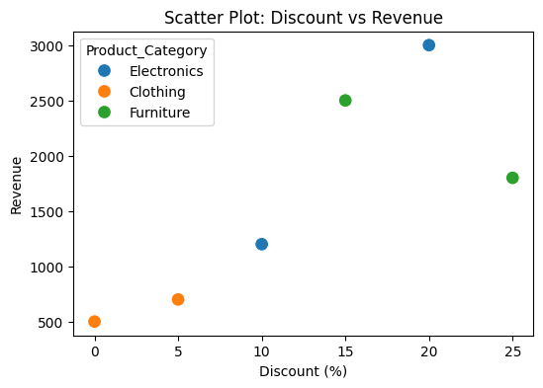**2. Findings:** Discounts of 20% (e.g., 3,000) and 15% (e.g., 2,500) correlate with the highest individual sales, supporting the example’s suggestion that over 15% boosts sales. However, the sample size is small, and 0% discounts still contribute 1,000 across two orders.

**Insight**: Discounts above 15% appear effective for high-value sales, but zero discounts maintain steady lower-value sales, suggesting a balanced approach.

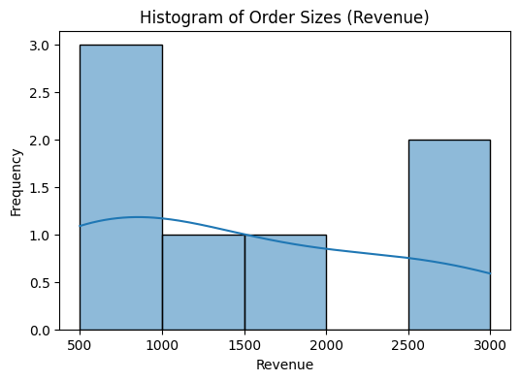

**3.Finding:** January 2024 leads with 3,000, aligning with the example’s holiday shopping trend, though the dataset is limited to one order per month in some cases.

**Insight:** January shows a peak, likely tied to post-holiday demand, offering a strategic window for marketing and inventory focus.

**4. Business Recommendations**

**Top Product Categories by Revenue:**

* Furniture leads with 4,300, followed by Electronics at 4,200.
* Clothing trails with 1,200, showing lower performance.

**Effective Discount Rates:**

* Discounts of 15-20% drive high sales (e.g., 3,000 at 20%, 2,500 at 15%).
* Zero discounts still contribute 1,000, suggesting a balanced approach works.

**Seasonal Sales Trends:**

* January peaks at 3,000, likely due to holiday shopping.
* February (2,500) and April (1,800) also show potential.

**These are the best recommended Actions:**

* Focus on Furniture and Electronics for marketing and stock.
* Use 15-20% discounts for big sales, avoid over-discounting.
* Plan big campaigns and inventory for January, prepare for February and April.